BUG REPORT

Project name: Adtingo Testing server: <http://clients.adtingo.com/index.php>

Developer: Manohar <http://admin.adtingo.com/manageadmin.php>

QA: Sudhindra <http://adtingo.com/>

Testing Environment: Windows 2003

**Bug ID: #AD_001**

**Bug Type:** UI/FUNTIONAL/NON FUNCTIONAL

**Description:** When the mail is successfully sent to the member after the administrator’s approval we see the following error.

**Steps to reproduce:** After the email sent to member-> open the mail and check 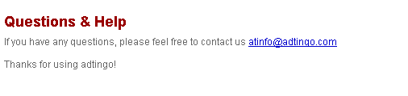

In the email sent for Campaign there is no space between (at info@adtingo.com) of email address.

**Developer comments:**

**Status:** Closed

**Bug ID: #AD_002**

**Bug Type: UI/ Functional/Non-Functional**

**Description: In the mail sent from the client to the member is displaying the following error.**

**Steps to reproduce: Go to member mail address -> Check above - list of things to come (footer).**

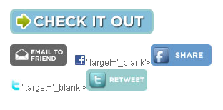

**It is displaying as target=-blank**

**Developer Comments:**

**Status: Closed**

**Bug ID: #AD_003**

Bug Type: UI/FUNTIONAL/NON FUNCTIONAL

Description: When the user logs in it prompts to create a new campaign in that page it’s showing the following bug. Here the spelling of summery should be **summary**

Steps to reproduce: Go to sign up-> Give all the information to create a new user -> then in this page you will see this bug.

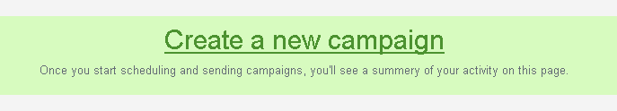

Spelling Mistake

Developer Comments:

Status: Closed

**Bug ID: #AD_004**

Bug Type: UI/FUNTIONAL/NON FUNCTIONAL

Description: In Reports although we open the mail in records it’s showing as mails not opened.

Steps to reproduce: Login as a Client -> Create a campaign -> send Campaign to the member -> Open members mail address -> Click on Clients campaign mail to see this bug.

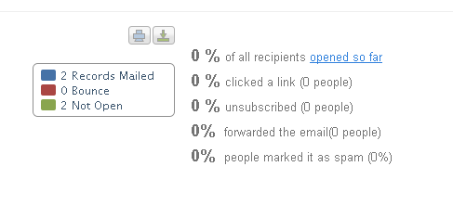

In reports displaying as mails not opened though it is opened in the mail.

Developer Comments:

Status: Open (leave now. I have to disscuss with shekar sir)

**Bug ID: #AD_005**

Bug Type: UI/FUNTIONAL/NON FUNCTIONAL

Description: In Member site when hit on login it’s displaying as “Not found Apologies”. Where in it is supposed to open a login page.

Steps to reproduce: Open member site -> Click on Login-> There we will get to see this bug.

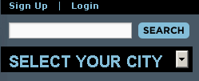

When we click on login in the member site we see the following bug

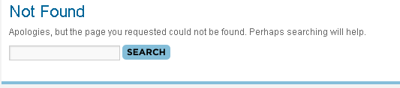

Developer Comments:

Status: Closed

**Bug ID: #AD_006**

Bug Type: UI/FUNTIONAL/NON FUNCTIONAL

Description: In Member site when we sign up to create a new user Name fields accepting spaces and **Numeric’s**

**In subscription list names of states are displayed twice.**

Steps to reproduce: Open member site -> Click on Sign up-> Fill in all the fields (fill the name field with numeric’s

Name fields accepting Numeric’s.

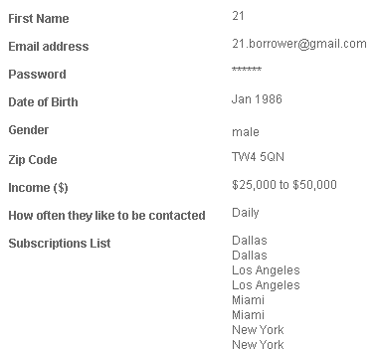Subscriptions list displaying twice.

Developer Comments:

Status: Closed

**Bug ID: #AD_007**

Bug Type: UI/FUNTIONAL/NON FUNCTIONAL

Description: Alt message is not displaying for edit button. Checked with Firefox and Internet Explorer.

Steps to reproduce: Open Admin Interface -> Go to Local do gooders-> when we place cursor on edit button alt message is not functioning, view and delete buttons are working fine.

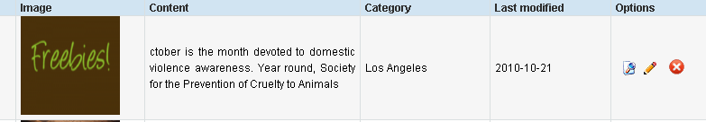

Alt message is not displaying for edit.

Developer Comments:

Status: Closed

**Bug ID: #AD_008**

Bug Type: UI/FUNTIONAL/NON FUNCTIONAL

Description: When we are clicking on the uploaded images of article in local do gooders it is re-directing to the admin login.

Steps to reproduce: Open Admin Interface -> Go to Local do gooders-> Click on images of articles -> there it is re-directing to the admin login.

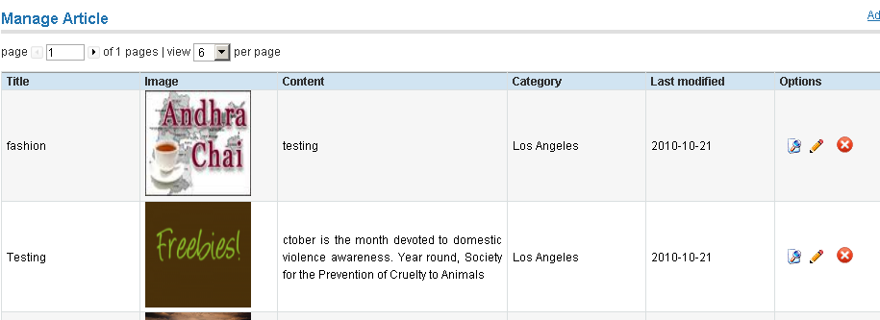

When we are clicking here it is re-directing to the admin login.

Developer Comments:

Status: Closed

**Bug ID: #AD_009**

Bug Type: UI/FUNTIONAL/NON FUNCTIONAL

Description: When we are creating an article in the local do gooders in admin interface in the content form cursor is starting from the middle of the page.

Steps to reproduce: Open Admin Interface -> Go to Local do gooders-> Create an article in local do gooders page -> there we see the cursor in the content starting from middle of the page.

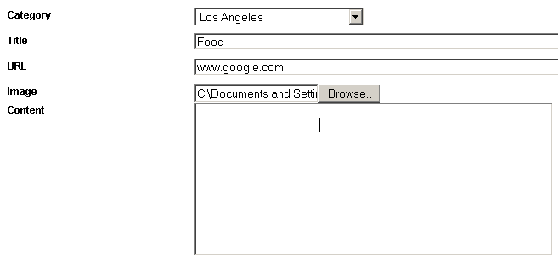

Cursor was starting from here.

Developer Comments:

Status: Closed

**Bug ID: #AD_010**

Bug Type: UI/FUNTIONAL/NON FUNCTIONAL

Description: Alt message missing in campaigns page in admin interface on EDIT button.

Steps to reproduce: Open Admin Interface -> Go to Campaigns-> place the mouse on edit button

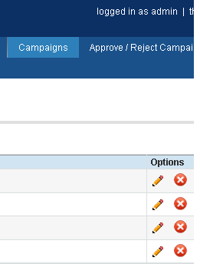

Developer Comments:

Status: Closed

**Bug ID: #AD_011**

Bug Type: UI/FUNTIONAL/NON FUNCTIONAL

Description: In admin panel when we click on –Local do gooders Tab- payment details tab comes down to the second row.

When we click on the campaign performance report or any other tab then payment details tab goes up.

Should be an **Alignment Issue**

Steps to reproduce: Open Admin Interface -> Click on Local Do-Gooders->



Payment Details tab in second row



Payment Details tab in first row

Developer Comments:

Status: Closed

**Bug ID: #AD_012**

Bug Type: UI/FUNTIONAL/NON FUNCTIONAL

Description: When we were trying to add a campaign from admin panel in the template it shows face book and twitter icons highlighted where in we intentionally gave the URL as [www.google.com](http://www.google.com)

Steps to reproduce: Login to Admin panel-> go to campaign tab-> Try to create a Campaign-> after filling the Details we see this.

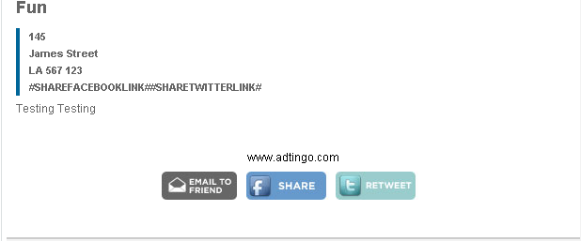

In place of icons it’s displaying this.

Developer Comments:

Status: Closed

**Bug ID: #AD_013**

Bug Type: UI/FUNTIONAL/NON FUNCTIONAL

Description: we see this below error when we were trying to create a new campaign

It happened for 3 or 4 times but now it is working fine, just wanted to keep you informed with this.

Steps to reproduce: Go to Client Site -> Login -> Try to create a new campaign.

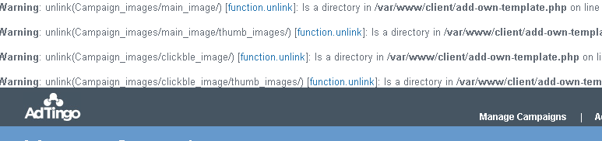

Developer Comments:

Status: Closed

**Bug ID: #AD_014**

Bug Type: UI/FUNTIONAL/NON FUNCTIONAL

Description: In internet explorer when we try to create new campaign after list segmentation page in ZIP CODE PAGE when we click on –skip the step- or – Next – button it’s not taking us to the next page.

Steps to reproduce: In Internet Explorer -> Open Client Site -> Try to create a new campaign.

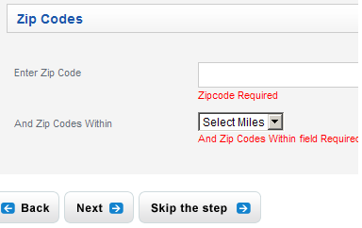

Developer Comments:

Status: Closed

**Bug ID: #AD_015**

Bug Type: UI/FUNTIONAL/NON FUNCTIONAL

Description: While creating a campaign as a client we can see Total no of Records, when we try to create a campaign in admin site Total no of records is not shown.

Steps to reproduce: Go to Client site -> Try to create a new campaign-> Total no of records is displayed in list segmentation page, where as in admin site we don’t see this.

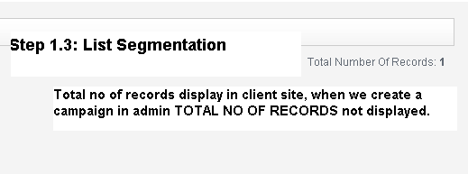

Developer Comments:

Status: Closed

**Bug ID: #AD_016**

Bug Type: UI/FUNTIONAL/NON FUNCTIONAL

Description: When we create campaign in the client site a validation should be fired when we cross the 250 words in the content.

Steps to reproduce: Go to Client site -> Try to create a new campaign-> In Campaign information page.

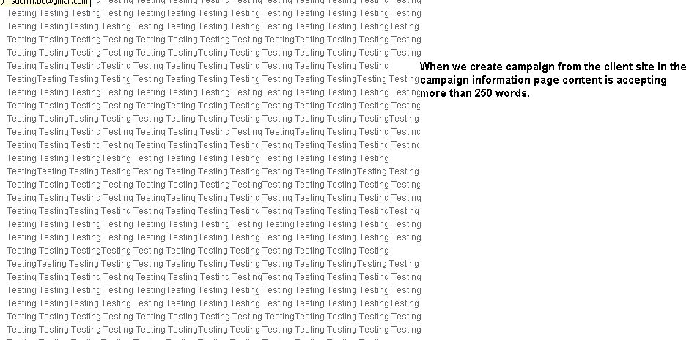

Developer Comments:

Status: Closed

**Bug ID: #AD_017**

Bug Type: UI/FUNTIONAL/NON FUNCTIONAL

Description: In the mail sent to the member from client site, in the footer Link10 Link & 10 are in separate lines. Should be same line.

Steps to reproduce: Go to Client site -> Try to create a new campaign-> In Campaign information page.

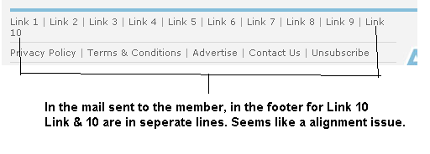

Developer Comments:

Status: Open

**Bug ID: #AD_018**

Bug Type: UI/FUNTIONAL/NON FUNCTIONAL

Description: when we try to manage clients from admin panel when clicking on arrow highlighted to next page arrow we see the link directing to client selection page.

Also when we click on the drop down of view per page, it is re-directing to the previous page.

Steps to reproduce: Go to Admin panel -> Select the client name-> after selecting the client we see this bug.

We see the bug when we click on these buttons.

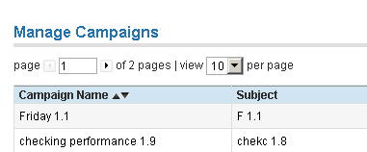

Developer Comments:

Status: Closed

**Bug ID: #AD_019**

Bug Type: UI/FUNTIONAL/NON FUNCTIONAL

Description: There are no limitations for contact info

Steps to reproduce: Login Admin panel -> Try to create a new campaign-> Try to fill in address.

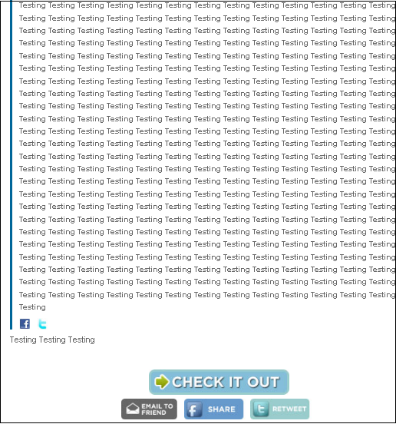

No Limitations to Contact Info (address)

Developer Comments:

Status: Close( no limit for contact info)

**Bug ID: #AD_020**

Bug Type: UI/FUNTIONAL/NON FUNCTIONAL

Description: When creating a template 2 in IE8 address is starting from the middle of the page.

Steps to reproduce: From Admin Panel -> Try to create a new campaign-> Fill in the form -> click on Preview.

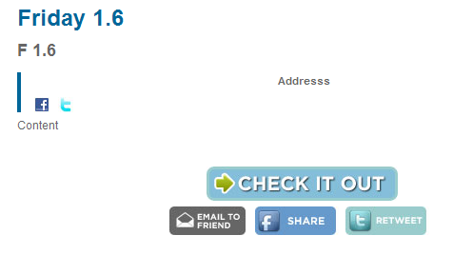

Address starting from middle of the page in template when created it on IE8.

Developer Comments:

Status: Closed

**Bug ID: #AD_021**

Bug Type: UI/FUNTIONAL/NON FUNCTIONAL

Description: When creating a campaign through admin panel in IE8, when selecting the Send to All (radio button) the other specify Number space should not be highlighted.

Steps to reproduce: From Admin Panel -> Try to create a new campaign-> **In Select the option to send campaign** page

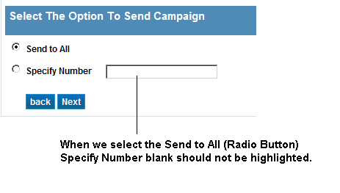

Developer Comments:

Status: Closed

**Bug ID: #AD_022**

Bug Type: UI/FUNTIONAL/NON FUNCTIONAL

Description: Back button is not functioning in all the pages in IE8, when creating a Campaign.

Steps to reproduce: From Admin Panel -> Try to create a new campaign-> click on back button.

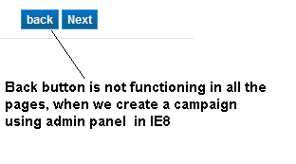

Developer Comments:

Status: Closed

**Bug ID: #AD_023**

Bug Type: UI/FUNTIONAL/NON FUNCTIONAL

Description: Spelling Mistake – Coantact info should be **Contact Info**.

Steps to reproduce: From Admin Panel -> Try to create a new campaign-> when filling the form we see this bug.

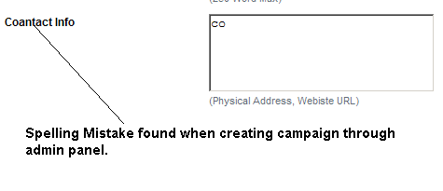

Developer Comments:

Status: Closed

**Bug ID: #AD_024**

Bug Type: UI/FUNTIONAL/NON FUNCTIONAL

Description: When creating campaign in IE8, when we upload main image single is not working there but then double click is working fine. Where as in the same functionality works fine with fire fox.

Steps to reproduce: From Admin Panel -> Try creating a campaign-> 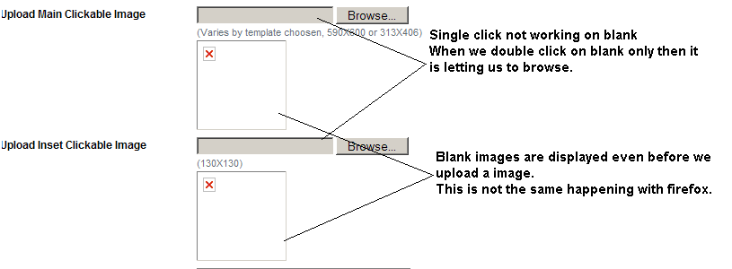

Developer Comments:

Status: Open:

**Bug ID: #AD_025**

Bug Type: UI/FUNTIONAL/NON FUNCTIONAL

Description: Edit functionality is not working when we create a campaign through admin panel.

Where as in the same functionality works fine with fire fox.

Steps to reproduce: From Admin Panel -> Try creating a campaign -> then go to any of the other tabs ->

When we come back check with EDIT tab.

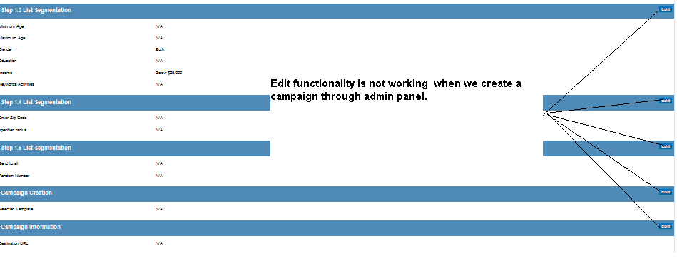

Developer Comments:

Status: Closed

**Bug ID: #AD_026**

Bug Type: UI/FUNTIONAL/NON FUNCTIONAL

Description: Zip code accepting Special characters.

Steps to reproduce: From Admin Panel -> Try creating a campaign->

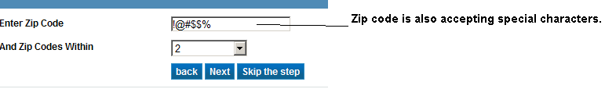

Developer Comments:

Status: Closed

**Bug ID: #AD_027**

Bug Type: UI/FUNTIONAL/NON FUNCTIONAL

Description: Text content & Contact Info space not taking any inputs in Chrome7.0

Steps to reproduce: From Admin Panel -> Try creating a campaign->

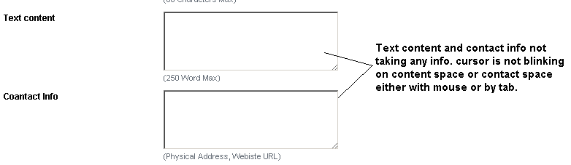

Developer Comments:

Status: Closed

**Bug ID: #AD_028**

Bug Type: UI/FUNTIONAL/NON FUNCTIONAL

Description: Before uploading the image we see this space.

Steps to reproduce: From Admin Panel -> Try creating a campaign->

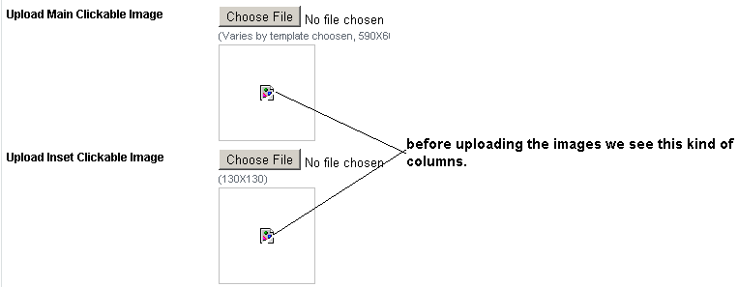

Developer Comments:

Status: Closed

**Bug ID: #AD_029**

Bug Type: UI/FUNTIONAL/NON FUNCTIONAL

Description: In Text Content letter c is not in capitals.

Steps to reproduce: From Admin Panel -> Try creating a campaign->

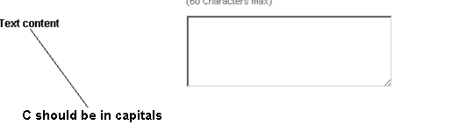

Developer Comments:

Status:closed

**Bug ID: #AD_030**

Bug Type: UI/FUNTIONAL/NON FUNCTIONAL

Description: In admin interface in Email Templates Tab Priview spelling should be PREVIEW.

Steps to reproduce: From Admin Panel -> Click on Email Templates->

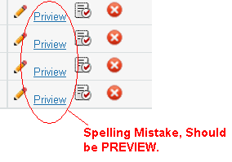

Developer Comments:

Status: Closed(we replaced img in the place of preview)